RESULTS

Table 1: Frequency Distribution of selected Variables of the samples (N=497)
Variables | Categories | Frequency | Percentage (%)
Sex | Male  Female | 288  209 | 57.9  42.1
Age | <1year  1.01-3.00years  3.01-5.00years  5.01-7.00years >7.00years | 217  211  32  16  19 | 43.8  42.6  6.5  3.2  3.8
Aetiology | Jaundice  Birth Asphyxia  Seizure  Others | 137  143  91  107 | 28.7  29.9  19.0  22.4
Referral center | Unth  Centres in Enugu  Centres outside Enugu | 404  56  25 | 83.3  11.5  5.2
Duration of Physiotherapy Treatment in Months | <6months  6-12months  13-36months  >36months | 293  132  64  8 | 59.0  26.6  12.9  1.6
Number of Treatment sessions | 0-10  11-20  21-30  31-40  >40 | 357  82  29  15  14 | 71.8  16.5  5.8  3.0  2.8
Treatment Density(No. of treatment sessions per week) | 1  2  3  >3 | 440  32  9  4 | 90.7  6.6  1.9  0.8
Caregiver | Mother  Father  Mother and father  Others | 381  44  38  34 | 76.7%  8.9%  7.6%  6.8%
Type of cerebral palsy | Spastic  Athetoid  Ataxic  Mixed | 274  74  45  90 | 56.7%  15.3%  9.3%  18.6%
Physiotherapy discharge documented | No  Yes | 459  38 | 92.4%  7.6%
Key: Unth=University of Nigeria Teaching Hospital
Bar chart 1: Shows the Frequency distribution of cases of cerebral palsy from year 2007 to 2016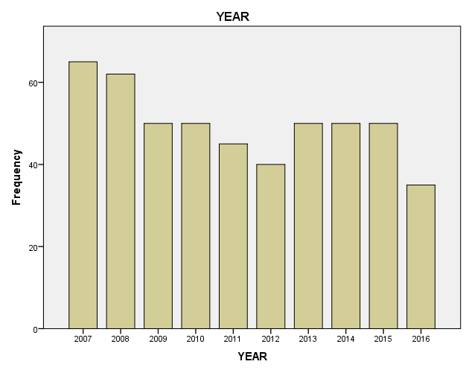
10.1%
7.0%
10.1%
10.1%
10.1%
8.0%
9.1%
12.5%
10.1%
13.1%

Bar chart 2: Shows the Frequency distribution of position of cerebral palsy children in the family
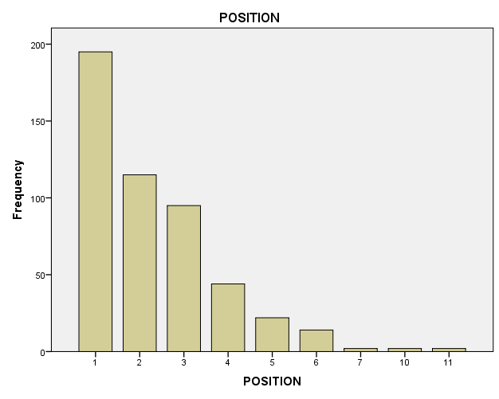
39.6%
23.3%
19.3%
8.9%
4.5%
2.8%
0.4%
0.4%
0.4%

Bar chart 3: Shows the Percentage distribution of the clinical presentations of cerebral palsy children.
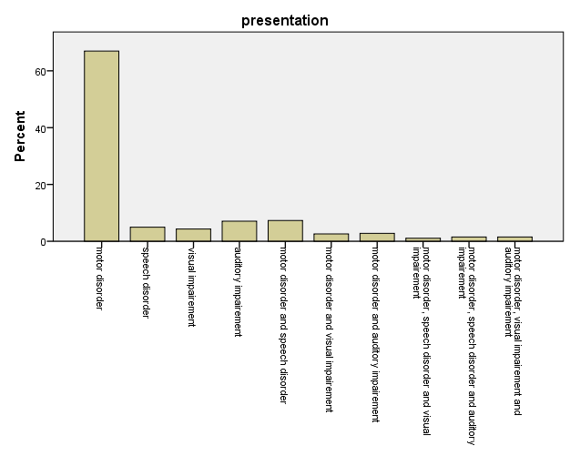
67.0
4.9
4.3
7.1
7.3
2.6
2.8
1.1
1.5
1.5

Table 2: Shows the association between type of cerebral palsy and treatment density (n=473)
Variables | Spastic type | Athetoid type | Ataxic type | Mixed type | Total | X²(P-value)
Treatment density |  |  |  |  |  | 9.444(0.397)
1 | 241 | 66 | 42 | 79 | 428(90.5%)
2 | 20 | 7 | 0 | 5 | 32(6.8%)
3 | 4 | 1 | 2 | 2 | 9(1.9%)
>3 | 2 | 0 | 0 | 2 | 4(0.8%)
Total | 267(56.4%) | 74(15.6%) | 44(9.3%) | 88(18.6%) | 473(100%)

Table 3: shows the association between type of cerebral palsy and cause of cerebral palsy (n=470)
Variables | Spastic | Athetoid | Ataxic | Mixed | Total | X²(P-value)
Jaundice | 80 | 21 | 13 | 21 | 135(28.7%) | 28.303(0.001*)
BirthAsphyxia | 90 | 14 | 13 | 25 | 142(30.2%)
Seizure | 56 | 10 | 3 | 19 | 88(18.7%)
Others | 40 | 29 | 13 | 23 | 105(22.3%)
Total | 266(56.6%) | 74(15.7%) | 42(8.9%) | 88(18.7%) | 470(100.0%)

Table 4: Shows the association between the type of cerebral palsy and duration of physiotherapy treatment (n=483)

Variables | Spastic | Athetoid | Ataxic | Mixed | Total | X²(P-value)
<6months | 176 | 40 | 31 | 36 | 283(58.6%) | 31.784(<0.0001)
6-12months | 58 | 23 | 10 | 37 | 128(26.5%)
13-36months | 39 | 10 | 3 | 12 | 64(13.3%)
>36months | 1 | 1 | 1 | 5 | 8(1.7%)
Total | 274(56.7%) | 74(15.3%) | 45(9.3%) | 90(18.6%) | 483(100.0)%

Table 5: Shows the association between the cause of cerebral palsy and the position of the child in the family (n=474)

Variables | Jaundice | Birth asphyxia | Seizure | Others | Total | X²(P-value)
1st child | 53 | 62 | 28 | 43 | 186(39.2%) | 60.719(<0.0001)*
2nd child | 33 | 32 | 26 | 20 | 111(23.4%)
3rd child | 33 | 25 | 25 | 11 | 94(19.8%)
4th child | 8 | 7 | 7 | 20 | 42(8.9%)
5th child | 5 | 6 | 2 | 9 | 22(4.6%)
Others | 4 | 10 | 2 | 3 | 19(4.0%)
Total | 136(28.7%) | 142(30.0%) | 90(19.0%) | 106(22.4%) | 474(100%0

